NEVER USE Word templates. ALL text should be 12 pt times new roman, on all pages, all the time. Delete this box and text prior to turning in your paper.

Title of Your Paper
Your Name
September 25, 2017

Introduction
One paragraph (or more) - Tell me about your town.
Example (Yes, this is where Dr. Kruger grew up):
The town of Columbiaville, Michigan is a quaint town about 30 minutes outside of Flint, Michigan. With a population of only 787 people, from the 2010 census, this small town is plagued with big problems. The median income for a household in the village was $39,844, and the median income for a family was $45,750 (cited). Males had a median income of $40,156 versus $20,000 for females (cited). The per capita income for the village was $16,216. About 3.2% of families and 4.3% of the population were below the poverty line, including 2.7% of those under age 18 (cited). It can be seen that this village with a small population not only is experiencing income inequality, but also has major public health concerns.

Explain the Health Issue
Paragraph 1-Tell me about the health issue you chose. What is the problem? Why is it a public health issue? What happens to people suffering from it?
Paragraph 2- Tell me about why this is an issue in the town you choose
Example:
Just like many other cities in the United States, Columbiaville is experiencing high rates or heroin overdoses. It can be seen in the news almost every week “Man dies of heroin overdose” or “Women found dead due to suspected overdose”. Heroin is an opioid drug made from morphine, a natural substance taken from the seed pod of the various opium poppy plants grown in Southeast and Southwest Asia, Mexico, and Colombia (Cite). Heroin enters the brain rapidly and binds to opioid receptors on cells located in many areas, especially those involved in feelings of pain and pleasure and in controlling heart rate, sleeping, and breathing (cite). This is a public health issue because people are dying at high rates from this drug all over the US. A heroin overdose occurs when a person uses enough of the drug to produce a life-threatening reaction or death (cite).
In the village of Columbiaville, there have been a total of 16 overdoes in the past year, with a total of 7 of these overdoses resulting in death (cite). With the village having so few residents, and many living in poverty this problem may continue to grow. The local health department is located one town over and has not received any grants to help combat the issue. Local residents fear for their neighbors, with no assistance in sight, it’s important to look at previous interventions to discover possible theoretically based interventions to help this community.

Social Ecological Model
Paragraph (s) 2-3 total - Explain this model and constructs that go with it, use peer reviewed sources to support each level.
Example:
The socio-ecological models were developed to further the understanding of the dynamic interrelations among various personal and environmental factors (cite). It was developed by_____. The levels within it include _______. This model can be used to understand the multi-level influence of heroin in Columbiaville.
At the individual level, studies have found that________ (Example of article https://www.ncbi.nlm.nih.gov/pmc/articles/PMC3520938/). At the interpersonal level, it is found that_____ (Example of article https://www.ncbi.nlm.nih.gov/pmc/articles/PMC1524736/). Continue to discuss levels how they relate to your topic.

Health Belief Model

Paragraph (s) 2-3 total - Explain this model and constructs that go with it, use peer reviewed sources to support each level.
Example:

The health belief model (HBM) is a psychological health behavior change model developed to explain and predict health-related behaviors, particularly in regard to the uptake of health services (cite). The health belief model was developed in the 1950s by social psychologists at the U.S. Public Health Service and remains one of the best known and most widely used theories in health behavior research (cite). The model includes the following constructs __________. This model could be used to help understand why people in Columbiaville, seek or do not seek treatment for their addiction to heroin.
Researchers have found that the strongest predictor of someone seeking help for an addiction is the perceived barriers (cite). Discuss each construct supported by research. (https://www.ncbi.nlm.nih.gov/pmc/articles/PMC5139619/ ) See example article.

Theory of Reasoned Action/Theory of Planned Behavior

Paragraph 1- Explain this model.
Bullet points for each construct and how it could be applied to this problem…Do not use “I”, “We”, “Us”, “You” or other terms in this category when discussing this.
Example:
The theory of reasoned action/planned behavior (TRA/TPB) is a theory that links one's beliefs and behavior. The theory states that attitude toward behavior, subjective norms, and perceived behavioral control, together shape an individual's behavioral intentions and behaviors (cite). The concept was proposed by Icek Ajzen to improve on the predictive power of the theory of reasoned action by including perceived behavioral control (Cite). This theory can be used to understand a multitude of health behaviors, in this case, it could help better understand why people in Columbiaville are using heroin.
***Do not use these in your paper, I copied and pasted for Wikipedia to provide you with sample text***
***Find a peer reviewed source or cite the chapter that your peers wrote***
- Normative belief: an individual's perception of social normative pressures, or relevant others' beliefs that he or she should or should not perform such behavior (cite).
  - How does this relate to the problem?
- Subjective norm: an individual's perception about the particular behavior, which is influenced by the judgment of significant others (e.g., parents, spouse, friends, teachers(cite).
  - How does this relate to the problem?
- Control beliefs: an individual's beliefs about the presence of factors that may facilitate or hinder performance of the behavior.] The concept of perceived behavioral control is conceptually related to self-efficacy (cite).
  - How does this relate to the problem?
- Perceived behavioral control: an individual's perceived ease or difficulty of performing the particular behavior. It is assumed that perceived behavioral control is determined by the total set of accessible control beliefs (cite)
  - How does this relate to the problem?

Conclusion

1 paragraph wrapping up your paper.

Example:

Like most areas of the country, the heroin epidemic has effected the village of Columbiaville. This public health problem has taken lives, yet outlined above are theories and models that could be used to help reduce the impact of the problem. The social ecological model provides an overview of different levels to help guide the intervention. Next, the health belief model helps to inform public health professionals why people are not seeking treatment. Finally, the TRA/TPB provides a framework for understanding why people are still using and how to help change behavioral intentions. This problem will not disappear overnight, but there are ways to help improve the situation for the residens of Columbaivlle.

References

American Psychological Association. (2009). Publication Manual of the American Psychological
association (6thed.). [book example]
Blavos, A., Sofalvi, A., & Hodges, B. (2017). How to cite in APA format: The information.
Journal of SUNY Cortland, 2(2), 1-10. [professional literature example]
Centers for Disease Control and Prevention. (2017). Home page. Retrieved September 25, 2017
from https://www.cdc.gov/. [website example]
- References are ALWAYS on a separate page.
- To get the “hanging indent” you must hit “enter” and then “tab”

Appendix A
Page Headers

In order to include “running head on the first page, you MUST select “different first page.” Hint:
- Select Different first page
- Insert page number
- THEN type in your Running Header
Make sure your header and footers are set at 0.5”

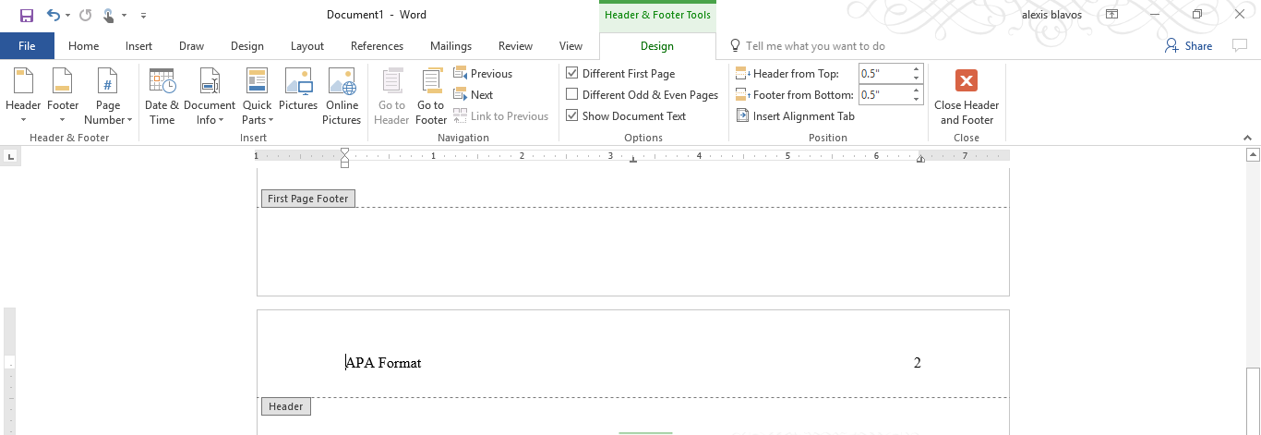
When you get to the second page, you will need to start over with setting up the header. Make sure it is 12 pt times new roman, doesn’t always default.

Appendix B
Setting Up Your Paragraph Formatting
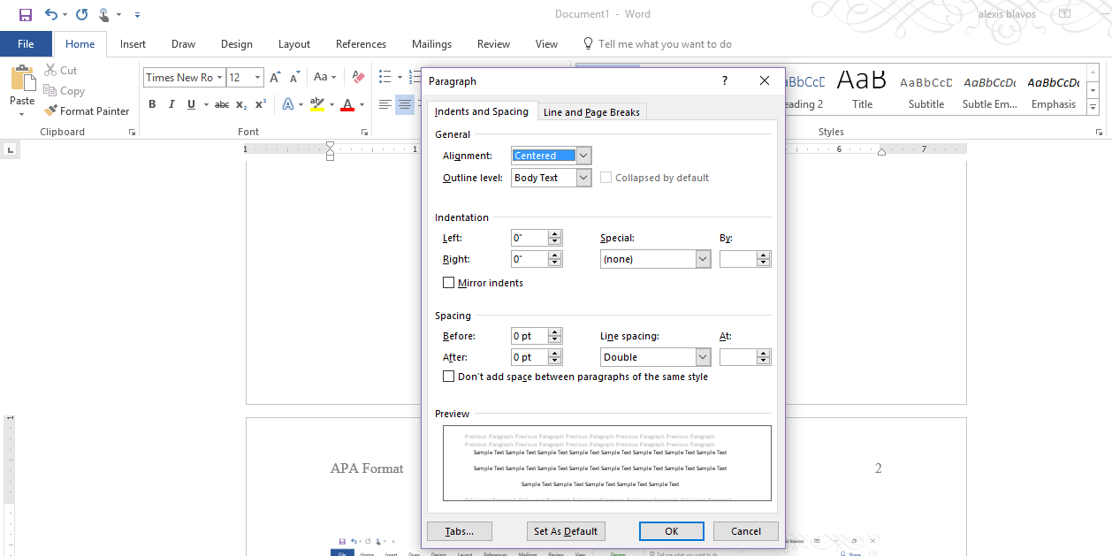
The ENTIRE paper should be double spaced, including the references.
Word does not always default to “0” before and after. Be sure this is set properly.

